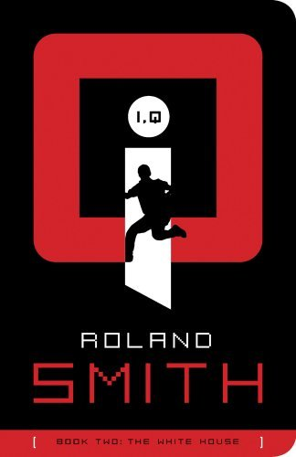

I, Q - Book Two: The White House - Reading Questions

Student Name __________________________ Date ____________________

Before reading:
Begin by writing a short summary of what happened in Book One.
Make a list of important characters from Book One. Write a fact or two about each one.
p. 1-30
1. What characters do you remember from the last story that appear in Book Two? (List them)
2. Where does the band Match arrive on the first page?
3. What do the kids do when they first arrive?
4. Angela tells Q she received a text from Malak. Then they are asked to go to the Oval Office to meet with the President. What could the text possibly mean? p. 14
5. Tell me about P.K. Who is he? What is his real name? What information do Q and Angela learn about the White House from P.K.?
6. It’s 3:30 am. Why do you suppose the President wants to see the two kids in his office?
7. The kids meet J.R. Culpepper. What do they talk about? What does he give the kids?
8. J.R. enters into the “hive” on p. 30 why is it called this?
p. 31-48
1. Why do Q and Angela get new phones?
2. What is plausible deniability?
3. Why does the President need plausible deniability? Explain.
4. What does Boone instruct the kids to do (on p. 34) while they are in the White House?
5. Do you suspect anything odd of Mr. Todd? Why or why not?
6. Who is Pat? Where was he? And Why?
7. What probing questions does Pat ask but Boone won't answer? Why?
8. Who all works in the W.H. according to P.K.? (List a few people)
9. What do you notice about Q and P.K.'s relationship? p. 48
p. 49-69
1. What is the Solarium?
2. Why is it ironic what Q and Angela are having for breakfast?
3. What is the Chief of Staff (Mr. Todd) doing in the residence?
4. What happens when Agent Norton appears?
5. Why would Mr. Todd threaten Agent Norton with working across the street?
6. Where are the tunnels in the White House?
7. What has P.K. done in order to hide the radio?
8. What are the “codes” and how does P.K. get them?
p. 70-92
1. Who is Arbuckle? Why do the kids meet him?
2. Why do Q and Angela want to invite people to the concert?
3. What does Q think he sees in Arbuckle for a split second?
4. What happens when Arbuckle asks for Q’s phone number?
5. What is Malak doing while Q and Angela are busy at the W.H.? Explain.
6. Predict why Agent Norton needs a ticket for Agent Callaghan.
7. What is Dirk Peski doing in the White House?
8. What does Dirk want from Q and Angela? Why?
9. What purpose does the card trick have?
p. 93-112
1. Who is Agent Call? p. 93
2. Why do you think the roadies weren't allowed in the W.H.? (Predict) p. 95
3. What do the watches represent? (The Seamaster watches from the President)
4. What do we learn about Agent Pat Callaghan and Agent Norton on p. 98?
5. Who is Warren Parker? p. 99
6. Explain what happens to the family that Malak was staying with, according to Boone. p. 100 (Write down as much as you can)
7. What do Marie and Art know that Buddy T. does not know?
8. Why can we assume that Malak is constantly being followed? p. 106-107
9. What is the relationship like between Malak and Amun?
10. Ziv is tracking Malak and Amun. What happens at the end of the chapter?

p. 113-133
1. What was it like for Q to live in a "glass house?"
2. When Q leaves the W.H. for the motor coach, what does he discover?
3. What do we learn about P.K.'s radio and the secret passages? Is this disappointing at all? Why or why not?
4. When Boone, Q and Angela leave the motor coach and go for a walk, Boone sends a message to Pat to "follow the dog." Why do you think Boone wants to speak to Pat?
5. Who is following Boone, Q and Angela? Is this suspicious or normal? Why? p. 122
6. Why is the SOS going to give Pat Callaghan a lie detector test?
7. What does this test monitor in order to catch a liar? p. 127
8. Why was Pat kicked out of working at the White House? (What happened in South Korea?) p. 130
9. What happens at the end of the chapter on p. 133? (Describe the scene)
p. 134-151
1. Who joins SOS?
2. Are the lie detector tests necessary in your opinion?
3. Malak is about to learn about the terrorist plan from Amun. Where are they going?
4. What were Malak and Amun’s first mission?
5. Malak meets Sean and Elise. Who are they?
6. Elise immediately does not believe Malak is Anmar. What happens next?
7. There is a bomb that goes off on p. 147. Then Boone learns news from Ziv that Malak is in trouble. Can you think of a way that Malak’s cover could be protected?
8. Angela and Q are heading back to the White House with Agent Norton and they bring him up to speed on all that has happened. Why is Charlie concerned about this ghost cell?
p. 152-169
1. Boone, Croc, X-Ray and Eben enter the apartment with Malak and Ziv and what do they find?
2. Boone tells Malak about the kids getting the watches from the President. We find out what changes Malak made to her watch – what were they? p. 156
3. Ziv has a plan to protect Malak’s cover – what does it involve? Do you think it will work?
4. What does Eben have to do for the plan to work?
5. We learn who Ziv really is at the end of the chapter. Who is he? What does Ziv do at the end of the chapter? p. 159
6. What leads does the FBI have about the bombings? p. 163
7. Q, Angela and P.K. are talking about why these terrorists are setting off bombs. This is a pretty deep discussion about religion as well as a war that has been going on for hundreds of years. What is your opinion on this issue? Discuss and describe. p. 165
8. Key words to define: caliphate, infidels, zealots – once you define these terms, explain how these terms relate to the discussion between Q, Angela and P.K.
p. 170-192
1. Malak is on the run. She has been shot. Where does she go first? How does she handle being wounded?
2. Eben runs after Malak and spots one of the ghost cell members. What does he do to him?
3. What is a drone? Why does X-Ray want it?
4. Malak gets back to the place where she stayed that morning and gets a phone call. What does she have to do now?
5. Malak meets Dr. Lennox. What do we learn about him? What does he have to do?
6. The concert is shortly about to happen but Boone sits down to talk to Q and Angela about Ziv. What is the new background information we learn about Ziv? p. 189-192
7. What side is Grandpa Ziv on according to Boone? What does this mean?
p. 193-211
1. Malak has been treated for her wound. Then she is put in a back of a car. What happens to her here? How does she respond?
2. Pat shares some information about Malak with Boone. Malak is “off the grid.” What does this mean?
3. Malak is being interrogated. She meets someone higher up in the cell than Amun. Who is it? p. 202
4. Mr. Todd and Agent Patrick Callaghan have a “showdown.” Why don’t the two of them like each other? What is the end result?
5. Amun’s father continues to question Malak. Malak learns that Ziv’s plan worked and Eben was successful. Malak tells a big lie at the end of the chapter – what is it? p. 211
p. 212-234
1. Q has to tell a lie to P.K. to cover for Angela on why she is so upset. What lie does he tell P.K.?
2. Malak passes Amun’s test so far – what does he explain to her about the next missions?
3. Considering all you know and all that has happened, what do you suspect the next mission could entail? Make a prediction.
4. Q feels “the itch” on p. 223. What does having “the itch” mean? Take a guess.
5. Q meets Wayne Arbuckle’s wife named Lillian at the concert. Who is she really?
6. The leopard explains that there will be a kidnapping. Who is going to be kidnapped?
7. Who are the moles in the White House?
8. Summarize what the note says that Malak gives to Q. What are his instructions to do with it? p. 230-231
9. Q and Angela speak on the phone about the invitation. Why does Q believe Angela is going to be so upset with him?
p. 235-End of story
1. Malak and Arbuckle are standing next to the First Daughter Bethany. Malak does something that she wasn’t supposed to do at the end of the chapter – what is it? p. 238
2. Q gets trapped somewhere – where is he stuck? How does he get out?
3. Q explains that they need to find P.K. What is the real reason why can’t they alert the Secret Service that P.K. is being kidnapped?
4. What did Malak do to Bethany’s drink?
5. What does Arbuckle do on his cell phone on p. 244?
6. Angela and Q eventually find P.K. with Conrad. P.K. was drugged. What happens next? Describe the major events occurring at the end of the story.
7. How does J.R. respond when he reads Malak’s note? What does Boone suggest they do?
8. J.R. gets a text during the debriefing. Who has Q’s phone? What does the text to J.R. say?
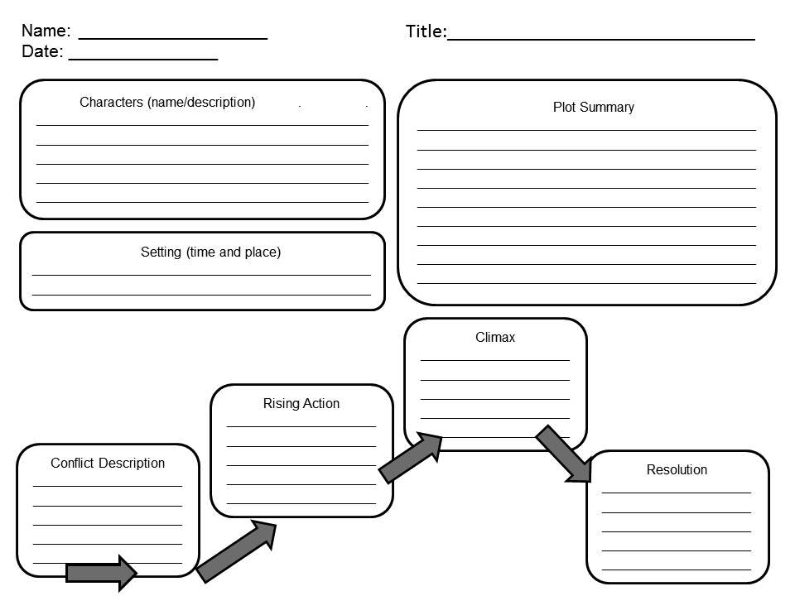

Graphic Organizer Courtesy of: http://tipsandtricksteacher.blogspot.com/2012/08/upper-elementary-middle-school-reading.html
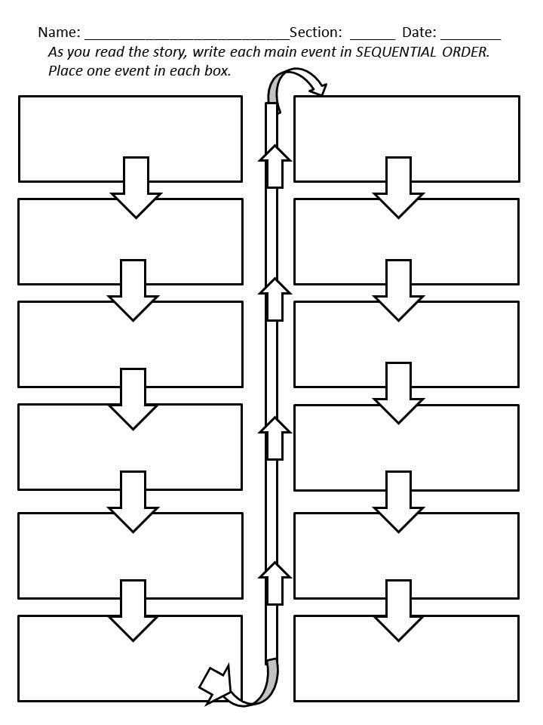

Graphic Organizer Courtesy of: http://tipsandtricksteacher.blogspot.com/2012/08/upper-elementary-middle-school-reading.html

Vocabulary Words for Book Two

p. 1-30
1. pugnacious – p. 8
2. aglow – p. 8
3. nocturnal – p. 11
4. imminent – p. 14
5. consultant – p. 16
6. diversionary – p. 21
7. extraterrestrials – p. 24
8. glower – p. 25

p. 31-48
1. plausible – p. 33
2. perpetual – p. 27
3. congealed – p. 45

p. 49-69
1. starched – p. 50
2. revolted – p. 51
3. credible – p. 55

p. 70-92
1. presume – p. 72
2. perplexed – p. 73
3. imperceptible – p. 73
4. conspiratorially – p. 82
5. subsidize – p. 85
6. inexplicably – p. 85
7. oblivious – p. 86
8. calligraphy – p. 89

p. 93-112
1. etched – p. 97
2. impeccable – p. 99
3. manifests – p. 100
4. petulant – p. 107

p. 113-133
1. premise – p. 115
2. diplomat – p. 118
3. blather – p. 119
4. adjoining – p. 124
5. pupil dilation – p. 127
6. tactical – p. 132

p. 134-169
1. suppressor – p. 144
2. infrastructure – p. 159
3. impeached – p. 164

p. 170-192
1. drone – p. 175
2. indispensable – p. 177
3. elite – p. 191

p. 193-211
1. brandishing – p. 193
2. revelation – p. 202
3. residue – p. 205

p. 212-234
1. jihad – p. 215
2. searing – p. 216
3. jockeying – p. 222
4. imperative – p. 226
5. badgered – p. 233

p. 235-End of story
1. hors d’oeuvres – p. 234
2. aborted – p. 235
3. hypothermia – p. 240
4. euphoria – p. 243
5. passivity – p. 243

I, Q - Book Two: The White House Power Point Project – Direction Sheet

You will create a power point as a final project for this book.

You will need at least 12 slides for this project. Your project can have more slides than 12 if needed.

The title of your slides: (or some kind of variation of this)

- Title Slide

- Major Characters Plus descriptions

- Minor Characters Plus descriptions

- Setting

- Protagonist Plus descriptions (look up the meaning if you aren’t sure what this is)

- Antagonist Plus descriptions (look up the meaning if you aren’t sure what this is)

- Conflict (there are a lot – choose at least 3 major conflicts in the story)

- Plot Twists (describe at least 3 plot twists)

- Resolution (describe the end of the story)

- Make a Prediction on Book Three, Kitty Hawk

- Favorite part of the story

- Reference Slide (This would include the proper citation of the book we read)

Include images in your presentation and include transitions between slides!

Due Date _________________________
Student Rubric for Power Point Presentation

Your Name (s) _____________Your Section ______________Date of Presentation ________

I, Q – Book Two: The White House Power Point Rubric

_________5 points Major Characters Plus descriptions
_________5 points Minor Characters Plus descriptions
_________5 points Setting
_________5 points Protagonist Plus descriptions
_________5 points Antagonist Plus descriptions
_________5 points Conflict (must have at least 3 major conflicts in the story)
_________5 points Plot Twists (describe at least 3 plot twists)
_________5 points Resolution (describe the end of the story)
_________5 points Prediction on Book Three – Kitty Hawk
_________5 points Favorite part of the story
_________5 points Images in your presentation and include transitions between slides
_________5 points References on the last page (including proper citation of the book we read)
_________15 points Presenter spoke loud enough, knew their content and used teamwork (if
you worked with a partner)

_________/75 points Your score

Feedback from Your Teacher:

