I, Q Book Three: Kitty Hawk - Reading Questions

Student Name __________________________ Date ____________________

Before reading:
Begin by writing a short summary of what happened at the very end of Book Two.
p. 1-22
1. How is P.K. at the beginning of the story?
2. What does J.R. Culpepper mean when he says Bethany is Malak’s ticket to the “upper echelon of the cell?” P. 5
3. What is a spotter, according to Boone and Angela? P.7
4. Why would SOS have to be aware of potential spotters? (Predict/Guess)
5. What was the drone able to pick up while following the Chevy Tahoe on I-95 South? P. 9
6. What affect did the drug given to Bethany Culpepper have on her? P. 10
7. Who else is following Malak AKA the leopard and Bethany? P. 14
8. J.R. Culpepper calls Boone while in the situation room - What do they talk about? P. 16-17
9. So far what do we know about John Masters, the new addition to the SOS team? (List 3 important details) P. 18-21
10. What major problem has complicated the issue of the drone/SOS following Malak? P. 19-22
p. 23-49
1. When and how did J.R. meet John Masters? P. 24-26
2. Why does John envision Tyrone Boone as “Agent Hippy?” P. 26
3. What are the potential problems with the fact that Malak has Q’s iPhone? P. 31
4. Describe what happens when the Chevy Tahoe pulls into the rest area. P. 32
5. Why does Boone want SOS to get in front of the Tahoes?
6. The cell was worried about the “Eye in the Sky” – what could this be and why? P. 35-36
7. Why were Malak and Bethany under a tarp? P. 36
8. What does Q have to do to help SOS? What about Angela? P. 40-41
9. What does “Scuffed Boots” give to Malak while under the tarp? P. 46
10. What do Malak and “Scuffed Boots” discuss? Why is this risky? p. 49

p. 50-77
1. Why is Q feeling the itch while spotting for Tahoes with Croc? Who does he think he spotted?
2. What information does Angela pull up on the Internet about Peter “Speed” Paulsen?
3. What struggles does Felix have while following one of the Tahoes? P. 63
4. What happens when Felix spots a car pulled over with the hazard lights on?
5. Describe the 4 passengers in the car.
6. What did Felix discover was actually wrong with the car?
7. What does Felix have to do at the end of the chapter? Describe the scene.
8. Ziv and Eben have a plan to find out who is in the Tahoe heading eastbound – what is it?
9. Vanessa, Uly, and X-Ray are following a Tahoe headed westbound – how far are they from Boone and what is their predicament?
10. What is their plan to get a look inside of the car? Do you think it will work?
p. 78-95
1. Felix makes a call to Boone - what does Boone realize about the four Tahoes? P. 84
2. Ziv and Eben pull over the Tahoe they are following - what is the result? P. 87-88
3. Who is Alex Finn? P. 87
4. What does Uly discover about the passengers in the vehicle they pass? P. 88-89
5. Why does Boone want everyone to continue following the two Tahoes?
6. Explain why Boone does not want to inform the President about the other car bombs.
7. Do you agree with his decision? Why or why not? P. 93-95
8. Who is driving the yellow Hummer? Why might this be a problem for Q, Angela and Boone?
p. 96-110
1. What is Q’s plan to help keep his dad away from the fiasco with the President’s daughter?
2. What is ombrophobia? P.97
3. According to Q, is his dad really harmless? Explain your answer.
4. What do Q and his dad discuss in the Hummer? Explain at least 2 or 3 topics.
5. Where is Q’s dad headed after he met up with the tour?
6. Where and why does Boone ask Q to meet him?
7. Why is Croc acting so oddly in the Hummer? Stop at P. 106 to answer.
8. Where did Malak and Bethany end up after the switch at the rest area?
9. How does Bethany respond to everything Malak told her?
10. How would you have responded in that situation if you were Bethany?
p. 111-134
1. Make a guess. Why does Q’s dad keep referring to Q’s step-dad as “what’s-his-name”?
2. Describe Speed Paulsen’s appearance.
3. How do Q and Angela slip away undetected from Speed Paulsen?
4. Based on the crowd around Q’s dad, did he really want to be incognito? Explain your reason.
5. Boone picks up Q and Angela outside the hospital – why does Q think that the world must be like “one huge, used car lot” to all spies? P. 121
6. What is the ball and cup trick? How does it apply to Malak and Bethany? How did Q figure out this trick anyway?
7. Meanwhile John Masters is following another Tahoe and meets up with this crew at the Supercenter Wal-Mart. Why is Masters so concerned about checking for counter-surveillance?
8. Who does John Masters spot when he first enters Wal-Mart? Describe him.
9. Describe what happens when he runs into the other terrorists in the group. (He calls them T2, T3, T4)
p. 139-163
1. When John leaves Wal-Mart he bangs on a trailer door at 4am. Why?
2. What lie does he tell “Trailer Guy” about the groceries?
3. Q describes Boone as “annoyingly obtuse” – why does he think this? In your opinion, why is Boone always dodging personal questions?
4. What does Boone reveal about himself and about Croc to Q and Angela? P. 147-148
5. Who are the oldest members of SOS (except for Boone)?
6. What happened at the U.S.S. Cole in 2000? P. 150
7. Felix has to get info about Speed at the hospital but no one wants to give him any info. What does he do?
8. What do Eben and Ziv do to the bomb they find in the Tahoe near the memorial?
9. What does Malak discover is inside of the truck she is traveling in? P. 162
p. 164-185
1. Boone, Q and Angela hit a roadblock – what happened?
2. Boone and Croc go for a walk – what happens to Q and Angela at the end of the chapter Poof? P. 167-169
3. Boone asks a man in a red truck about where the white SUV went? What does he realize about the white Tahoe and the tracking device that John Masters had put on it?
4. Boone “blinked himself back to the Audi.” What does this mean Boone can do? P. 175
5. On p. 176, what does Boone whisper into Croc’s ear?
6. What information does T3 (Terrorist 3) ask Angela and Q?
7. Why does Q think it is lucky that the terrorists did not know about John Masters?
8. While Angela and Q are in the back of the car, they see Croc – what is so unusual about how Croc can move? P. 184-185
p. 189-202
1. John Masters and Boone are following the white Tahoe – what do J.R. Culpepper and Boone discuss at the beginning of the chapter?
2. Why does Boone want this to be an “Israeli Mossad operation” with no American involvement?
3. When the back of the truck opens, whom does Malak see? Describe the scene.
4. Who has more power in the ghost cell– Ariel or Anmar?
5. What does becoming “one of the five” mean for Anmar/Malak?
6. Ariel’s team of terrorists took Angela and Q – obviously, Malak did not know this since she was in the back of the truck. How do you think she is feeling about this situation?
7. “Dead Kids Tell No Tales” – a quote by Ariel – what can you assume will happen to Angela and Q? p. 197
8. Describe Boone’s plan, which he shares with Malak in the cemetery. What will Malak have to do? What will Eben and Ziv have to do?
9. What is Q’s job once they get to the house (after they take the boat ride)?
p. 203-222
1. Angela and Malak have a conversation on the boat ride – what does Malak plan to do about the group of five terrorists?
2. What does Malak want to do after this whole ordeal is over?
3. Why does Q think Boone won’t really need his cell phone video?
4. Describe the house where they dock the boat. P. 210-211
5. How does Q disguise the fact that he is holding a phone and taking a video?
6. Who is in the room when Q and Angela enter the house? Why is Q really not that surprised?
7. Who appears behind one of the terrorists in the woods? What signal does he send to Q?
8. Who is Paul Smailes?
9. What does Paul (One of the Five) believe is/was the problem with the car bombs?
10. Who was the primary suspect at the U.S.S. Cole Memorial?
11. Describe how the voting works in the ghost cell. P. 220
12. Describe the raid – who was shot? How did Malak get out of the house with Paul? P. 222
p. 223-End of Book
1. The raid is over – what does Bethany say to Angela and Q before she leaves the house?
2. Boone says he needs to get the kids to the next concert – what is the location of this concert?
3. What do Q and his mom discuss over the phone?
4. Once they get back on the road, someone comes out of back of the coach – who is it?
5. Are you annoyed at this ending? Why or why not?
6. Make a prediction on what will happen to Malak and Paul and the rest of the ghost cell members in Book 4 once they get to Texas.

Vocabulary Words for the Entire Book
- Look up definitions for each word. Then, use each one in your own sentence.
p. 1-22
1. infiltrated – p. 3
2. upper echelon – p. 5
3. requisitioned – p. 8
4. silhouettes – p. 10

p. 23-49
1. concise – p. 25
2. expendable – p. 40
3. collateral damage – p. 46

p. 50-77
1. penitentiary – p. 58
2. billowing – p. 64
3. embankment – p. 69
4. formidable – p. 76

p. 78-95
1. defusing – p. 85
2. repertoire – p. 85
3. singed – p. 92

p. 96-110
1. chauffeur – p. 101
2. noncommittally – p. 102
3. deference – p. 107

p. 111-134
1. sheepish – p. 117
2. bouquet – p. 119
3. debunking – p. 124
4. insomniac – p. 128

p. 139-163
1. cobbling – p. 139
2. obtuse – p. 144
3. trudged – p. 153
4. perpetrators – p. 154

p. 164-185
1. proceeded – p. 168
2. illusions – p. 184
3. hygiene – p. 184

p. 189-202
1. queasy – p. 193
2. interference – p. 196
3. vanish – p. 199
4. parameter – p. 201

p. 203-222
1. wistful – p. 205
2. vindictive – p. 206
3. configuration – p. 215
4. prevail – p. 221

p. 223-End of Book
1. gratitude – p. 224
2. cargo – p. 227

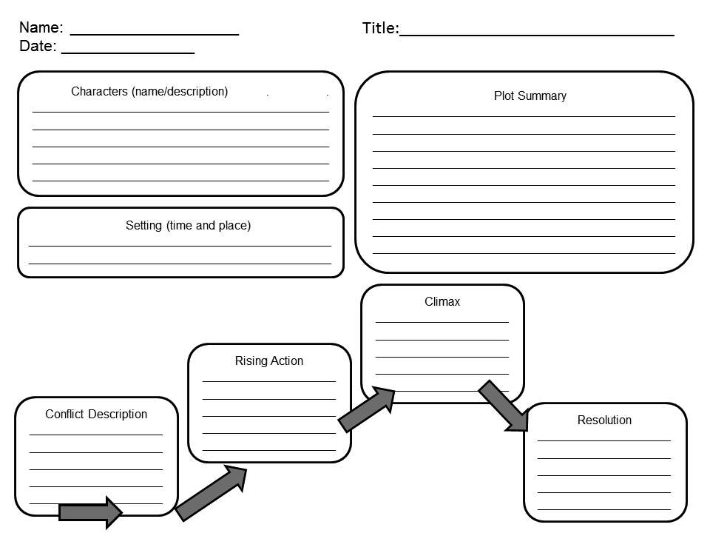

Graphic Organizer Courtesy of: http://tipsandtricksteacher.blogspot.com/2012/08/upper-elementary-middle-school-reading.html
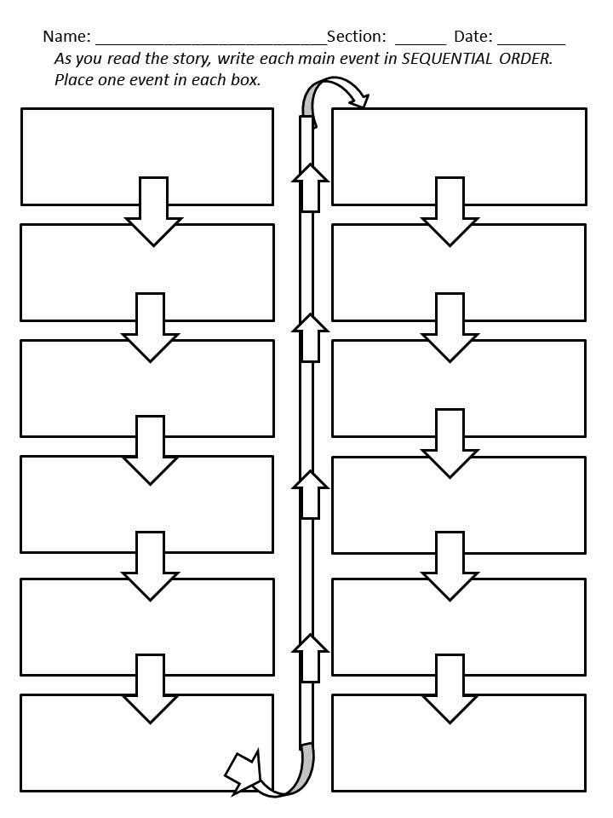

Graphic Organizer Courtesy of: http://tipsandtricksteacher.blogspot.com/2012/08/upper-elementary-middle-school-reading.html

I, Q - Book Three: Kitty Hawk Power Point Project – Direction Sheet

You will create a power point as a final project for this book.

You will need at least 12 slides for this project. Your project can have more slides than 12 if needed.

The title of your slides: (or some kind of variation of this)

- Title Slide

- Major Characters Plus descriptions

- Minor Characters Plus descriptions

- Setting

- Protagonist Plus descriptions (look up the meaning if you aren’t sure what this is)

- Antagonist Plus descriptions (look up the meaning if you aren’t sure what this is)

- Conflict (there are a lot – choose at least 3 major conflicts in the story)

- Plot Twists (describe at least 3 plot twists)

- Resolution (describe the end of the story)

- Make a Prediction on Book Four – The Alamo

- Favorite part of the story

- Reference Slide (This would include the proper citation of the book we read)

Include images in your presentation and include transitions between slides!

Due Date _________________________
Student Rubric for Power Point Presentation

Your Name (s) _____________Your Section ______________Date of Presentation ________

I, Q – Book Three: Kitty Hawk Power Point Rubric

_________5 points Major Characters Plus descriptions
_________5 points Minor Characters Plus descriptions
_________5 points Setting
_________5 points Protagonist Plus descriptions
_________5 points Antagonist Plus descriptions
_________5 points Conflict (must have at least 3 major conflicts in the story)
_________5 points Plot Twists (describe at least 3 plot twists)
_________5 points Resolution (describe the end of the story)
_________5 points Prediction on Book Four – The Alamo
_________5 points Favorite part of the story
_________5 points Images in your presentation and include transitions between slides
_________5 points References on the last page (including proper citation of the book we read)
_________15 points Presenter spoke loud enough, knew their content and used teamwork (if
you worked with a partner)

_________/75 points Your score

Feedback from Your Teacher:

